North Carolina Presbyterian Historical Society
Winter, 2012

Spring Tour: April 13-14
Mecklenburg’s Presbyterians (and one Baptist offspring!)


Billy Graham Homestead and Library www.360charlotte.com

Mecklenburg County and the city of Charlotte have been full of Presbyterians from their beginnings. As early as the 1740s, the area was settled primarily by Scotch-Irish families moving down the Great Wagon Road from Virginia and Pennsylvania. Seven Presbyterian churches (the “Seven Sisters”) were organized in this region before the Revolution—Sugaw Creek (1756), Steele Creek (1760), Hopewell (1762), Poplar Tent (1764), Centre (1765), Providence (1767), and Philadelphia (1770). We will be visiting three of these on our tour, and one of their many daughter churches, Pleasant Hill (1836).
Among the graves at Steele Creek, which date from 1763 onward, are those of the parents of one of the world’s most famous Baptists – the evangelist, Rev. Billy Graham. Nearby is the Billy Graham Library, documenting his life’s work, and also the reconstructed Graham family home. Our meeting will begin at noon on Friday with a guided tour of that facility. One area is dedicated to Ruth Bell Graham, the daughter of Presbyterian missionaries, who remained a Presbyterian for most of her life.
Pleasant Hill is a daughter church of Steele Creek, organized in 1836, primarily because at times the nearly impassible roads made it difficult for Presbyterians in the area to get to Steele Creek. We will visit the old and quite interesting cemetery there.
The present church at Steele Creek, built of handmade bricks, is the fifth or sixth sanctuary, and was completed in 1889. Its cemetery has probably the county’s finest collection of 18th and 19th century headstones. Although Steele Creek was organized in 1760, it is thought that there may have been a congregation there as early as 1745. Their first pastor, Robert Henry, came in 1766, but died the following year. The Rev. James McRee then served from 1778 to 1797, but many members left the congregation when he introduced the singing of hymns, in addition to psalms. During the Civil War, two hundred and four men from the church enlisted, and one hundred and one are buried in the cemetery. One of its best-known current members is Price H. Gwynn III, former moderator of the PCUSA General Assembly.
Saturday morning we will visit the birthplace of President James Knox Polk, who served in the White House from 1845-1849. His mother was a devout Presbyterian, a descendant of the brother of the reformer John Knox, and a member of Providence Presbyterian Church. However, the minister at Providence, Rev. James Wallis, refused to baptize her son James when the father, Samuel Polk, refused to declare himself a Christian. Although the family moved to Tennessee when Polk was 11, he later returned to attend UNC. Elected a congressman from Tennessee at the age of 29, he eventually became Speaker of the House, was elected President at the age of 49, and led the nation during the Mexican-American War. He died of cholera three months after his term ended, and was finally baptized on his deathbed, albeit by a Methodist!
The Providence congregation, first mentioned in synod minutes in 1765, was organized in 1767 by the Rev. William Richardson, uncle of the Revolutionary War hero and later governor, William R. Davie.

During the Revolution, the forces of both Cornwallis and Davie moved through the area.
From 1775 to 1928, the church provided elementary school facilities for the community of Providence. Providence Academy was established by the church in 1792, and Providence Female Academy in 1852. The church has also had strong ties with Davidson College.
The present sanctuary was built in 1858, with large galleries for the enslaved members, who comprised 33% of the communicants. After the Civil War, most of these left to form Murkland Presbyterian and Jonesville AME Zion. A few remained in the congregation until the 1890s.
The oldest marked grave (1764) in the large cemetery is placed near the “preaching rock” where Alexander Craighead of Sugaw Creek held occasional services before the congregation was organized. In recent years the slave portion of the cemetery has been identified, studied, and reconsecrated.
Philadelphia Presbyterian Church was organized in 1770 as Clear Creek Presbyterian, meeting in what was known as the Rocky Spring Meeting House. When the meeting house burned in 1780, the congregation moved about two miles away and changed its name to Philadelphia, as it was no longer near Clear Creek. It moved to its present site in 1826.
The large cemetery across the street dates from 1826. Since 2003, volunteers have worked to clear, restore, and record burials at the cemeteries at both of the previous sites. Three signers of the Mecklenburg Declaration are thought to have been buried in the one-acre cemetery at the Rocky Spring site, but only one has a marked grave. Most of the graves there are marked only with field stones. Outside the wall at the second site are the mostly unmarked graves of over 200 slaves of church members.
Mecklenburg County is wonderfully rich in Presbyterian history, and only a few of the stories can even be mentioned here. We hope you can come with us! More details of the tour and the registration form are on pages 6-7.

Need a ride?
We may not be able to help, but if you need a ride, please call Ann and John Myhre, (919) 772-5514. It is possible that someone who is planning to go would be able to take you. They could give you the names of some people to ask.

Plan Ahead!
Our Annual Fall Meeting this year will be on Saturday, October 13, at St. Andrews University in Laurinburg. That morning we will be visiting the new facility for the Scottish Heritage Center, headed by Bill Caudill. Last year St. Andrews entered into a partnership with Webber International University in Florida, but the SHC, the pipe band, and other programs will continue to celebrate our region’s historic connection with Scotland. Information on the Center and this year’s Scottish Heritage Symposium at St. Andrews, Mar. 16-18, can be found at http://www.sapc.edu/shc. And don’t forget to circle October 13 on your calendar! We hope you can join us.

News of the Scott Family Collection
Our newsletter doesn’t usually contain anything like new news, but your editor did just receive an email invitation to be shared with our members. On the afternoon of March 11, an oil portrait of the Rev. A. G. Hughes will be presented to the Scott Family Collection at Alamance Community College in Graham. Mr. Hughes (1810-1873) was principal of the Oxford Female Academy in the 1830s, later served as minister to both the Cross Roads and Hawfields Presbyterian churches in the mid-1800s, and was the uncle of Mrs. Lizzie Hughes Scott, grandmother of Gov. Bob Scott. The Scott collection includes papers of the family, photographs, and exhibits on the major areas of their influence: agribusiness, education, medicine, public service, and religion, including some history of the Hawfields church. It is located on part of the campus donated by the Scott family. To schedule a visit, call curator Peggy Boswell at (336) 506-4203.

Report on Fall Meeting, 2011, in Warrenton

We had a great fall meeting last October in the beautiful little town of Warrenton. The First Presbyterian Church was our host, and we met in the sanctuary that dates to 1855.
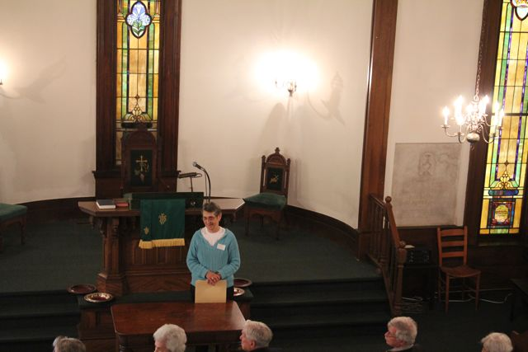

The Clerk of Session, Mrs. Candy White, told us about the history of the church. The beautiful carved pulpit and probably the building itself were designed by the 19th-century Warrenton architect, Jacob Holt.

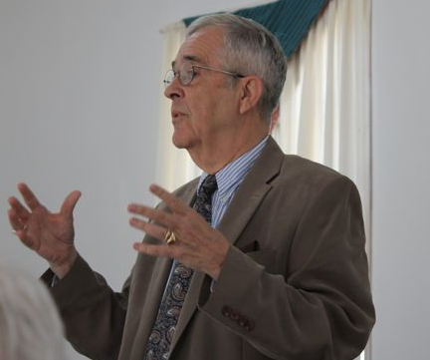

Our morning speaker was Dr. William S. Price, Jr., retired director of the NC Div. of Archives and History and professor emeritus at Meredith College. Dr. Price told us wonderful stories about the early days of Warrenton, when it was the thriving center of a rich agricultural district, and he also reminisced about the Warren County he knew when growing up there with his brother Reynolds. He closed with a reading from the writings of Reynolds Price, who had recently died.
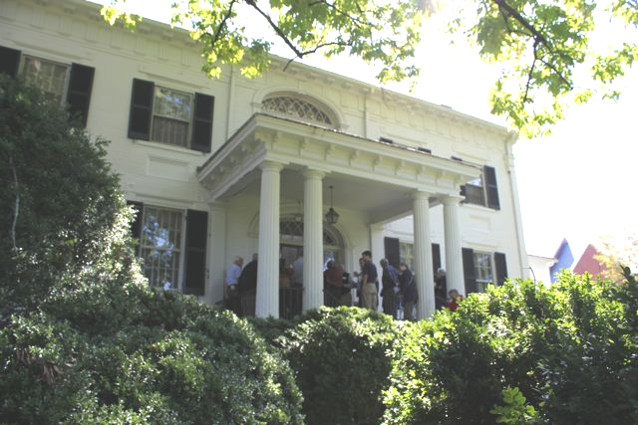

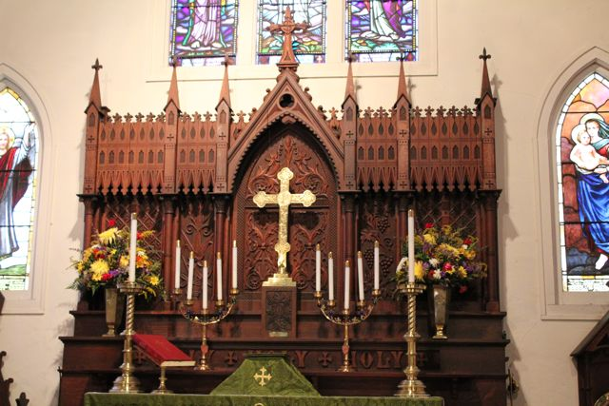
Mr. Richard Hunter then led us on a walking tour of downtown Warrenton. Our first stop was the magnificent home of William Eaton, built in 1843 as a summer home in which his daughter might entertain her friends.

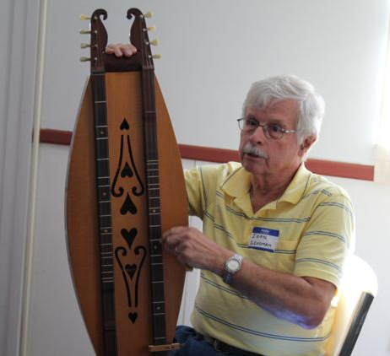
Our next stop was
the Episcopal church, with
its beautiful windows and
carved altar.

On our return to First Presbyterian, our lunch was waiting. Afterwards John Goodman, the former presbytery executive of Coastal Carolina, entertained us with folklore and song, playing his splendid mountain dulcimer. A brief business meeting followed, and the meeting closed.

Executive Board Members

John Myhre, President and Acting Treasurer
1005 Park Ave., Garner, NC 27529
Phone: (919) 772-5514
E-mail: johnmyhre@nc.rr.com

Joy Heitmann, Secretary
5021 Elaine Ave., Raleigh, NC 27610
Phone: (919) 862-0529
E-mail: joy_heitmann@mindspring.com

Tony Brewer, Program Chair
915 Evans Dr., Sanford, NC 27330
Phone: (919) 776-8091
Email: abrewer8091@windstream.net

Sally MacLeod Owens, Membership Chair
710 N. Person Street #204, Raleigh, NC 27604
Phone: (919)-835-0920
Email: sally.owens76@gmail.com

Ann Myhre, Awards Chair
1005 Park Ave., Garner, NC 27529
Phone: (919) 772-5514
E-mail: annmyhre@nc.rr.com

Sam Martin, Publicity Chair
P.O. Box 1037, Biscoe, NC 27209-1037
Phone: (910) 428-4165
E-mail: smartin8@embarqmail.com

Barbara T. Cain, Newsletter Editor
1041 Shelley Road, Raleigh, NC 27609
Phone: (919)-782-0944
E-mail: btcain@nc.rr.com

Dr. Donald B. Saunders, Past President
1739 Sunset Drive, Blowing Rock, NC 28605
Phone: (828) 295-8917
E-mail: saundersdb@appstate.edu

Executive Board Meeting
Jan. 14, 2012
The executive board of this society met on Saturday, January 14, at the home of Ann and John Myhre in Garner. Program Chairman Tony Brewer and Past President Don Saunders were unable to attend. Sam Martin, who has been working with Tony on plans for the Spring Tour, was able to give us the details for April 13-14. The fall meeting was discussed, and it was decided to meet on Sat., Oct. 13, at St. Andrews University in Laurinburg, especially visiting the Scottish Heritage Center there. Looking further ahead, the region of Tarboro/Wilson/Scotland Neck was suggested as a possible area for the Spring Tour, 2013. Suggestions for tours are always welcome.
Our Publicity Chairman Sam Martin also reported on his project of recognizing on behalf of our Society all Presbyterian churches that are celebrating important anniversaries (see next page). This is done primarily at the presbytery meetings.
Because of the rising cost of postage, it was decided to send the annual membership letters by email to those whose email addresses we have. This is only one quarter of the membership, but we hope to increase the number. We may also try sending newsletters by email, inviting members to let us know by return email if they prefer to receive a paper version.
We are running behind on our selection of officers, since the nominating committee last fall did not meet, and we had to defer the election of the president, secretary, and membership chair until this spring. Since the death of our treasurer Arthur Burgess, our president John Myhre has handled the treasurer’s duties very well, but we should also elect a treasurer either this spring or at the appointed time next fall. At our January meeting, the president appointed another nominating committee: our former president Tom Spence, our out-going membership chair Sally Owens, and Sheila Brewer. Anyone with suggestions or willing to volunteer for a two-year term should contact one of them. Contact information is in the first column of this page.

North Carolina Presbyterian Historical Society
Recognition of Significant Anniversaries, 2012

Presbytery of Charlotte
Hopewell PC, Huntersville 250 years
Davidson College PC, Davidson 175 years
Pleasant Hill PC, Charlotte 175 years
Marks Creek PC, Hamlet 150 years
Banks PC, Waxhaw 125 years
Bethany PC, Monroe 100 years
Caldwell Memorial, Charlotte 100 years

Presbytery of Coastal Carolina
Grove PC, Kenansville 275 years
Rockfish PC, Wallace 275 years*
Euphronia PC, Sanford 200 years*
Culdee PC, West End 125 years
Harmony PC, Harrells 125 years
Maple Hill PC, Maple Hill 125 years
Phillippi PC, Raeford 125 years
Cape Fear PC, Lillington 100 years
Ephesus PC, Lillington 100 years
First PC, Jacksonville 100 years
Highland PC, Fayetteville 100 years

Vass PC, Vass 100 years
West End PC, West End 100 years

Presbytery of New Hope
Little River PC, Hurdle Mills 250 years
Mount Pleasant PC, Willow Springs 100 years
Oak Grove PC, Kenly 100 years

Salem Presbytery
Alamance PC, Greensboro 250 years
Bethel PC, McLeansville 200 years
Sandy Ridge PC, Sandy Ridge 175 years
Wilkesboro PC, Wilkesboro 175 years
First PC, Winston-Salem 150 years
Rumple Memorial, Blowing Rock 125 years
Westminster, Greensboro 125 years

Presbytery of Western North Carolina
Conley Memorial PC, Marion 125 years
Newland PC, Newland 100 years
Grassy Creek PC, Spruce Pine 100 years

* Conflicting information on beginning year.

In the past few years our society has begun compiling the dates for the organization of churches and recognizing those with significant anniversaries, usually at presbytery meetings. If your church is celebrating an anniversary and we do not have it listed, please let us know. If a congregation would like to have its certificate presented one Sunday in an “historical minute” during worship, please contact Sam Martin to arrange a time.

History Awards
Each spring our society gives awards for recently published church histories or history projects that are considered worthy. If you wish to nominate one such, please send the book or a description of the project to Awards Chairman Mrs. Ann Myhre by Thursday, April 5. Her contact information is on p. 4.

Last spring awards were given to the following:
Harold Monroe Thrower, The History of Raft Swamp and Philadelphus Presbyterian Churches
Donna Joy Johnson for Paw Creek Presbyterian Historical Records Website (http://pawcreek.homestead/com/PPCO1.html)
Rev. John H. Jackson for the history of Bethel Presbyterian Church, York County S.C.
Rev. John H. Jackson for Bethel Presbyterian Church, Vol. II, Bethel Cemetery, York County S.C.
Joy Heitmann for “The Antioch Soldiers’ Aid Society, “ North Carolina Genealogical Society Journal, Vol. 37, No. 1, February 2011

Congratulations to all of them!

Map of NCPHS Spring Tour, Apr. 13-14.

1. Billy Graham Library 5. Comfort Inn at Carowinds
2. Pleasant Hill Presbyterian Church 6. Providence Presbyterian Church
3. Steele Creek Presbyterian Church 7. Philadelphia Presbyterian Church
4. John’s Family Restaurant 8. Jimmie’s Restaurant

Recommended accommodations: Comfort Inn at Carowinds, 3725 Avenue of the Carolinas, Fort Mill, SC. Telephone: (803) 548-5200. Rooms for Friday night, April 13, have been set aside for us at the special price of $59.49 + tax. Tell them this is for the NC Presbyterian Historical Society meeting.
2012 SPRING TOUR SCHEDULE
Friday, April 13
12:00 Registration at Billy Graham Library, 4330 Westmont Drive, Charlotte
(Registration table on the patio)
12:30 Begin Tour of Library
3:00 Pleasant Hill Presbyterian Church, 15000 York Road , Charlotte
4:30 Steele Creek Presbyterian Church, 7404 Steele Creek Road, Charlotte.
6:00 Dinner at John’s Family Restaurant, 2002 Westinghouse Blvd., Charlotte
7:30 Speaker / Program at restaurant
8:30 Check-in at Comfort Inn, 3725 Avenue of the Carolinas, Fort Mill, SC
9:00 Board Meeting at Comfort Inn

Saturday, April 14
7:00-8:30 Breakfast and check-out at Comfort Inn
8:30 Leave Comfort Inn
9:00 Tour of James K. Polk Historic Site
10:30 Providence Presbyterian Church, 10140 Providence Church Lane, Charlotte
12:00 Philadelphia Presbyterian Church, 11501 Bain School Road, Mint Hill
1:30 Lunch at Jimmie’s Restaurant , 7024 Brighton Park Drive, Mint Hill
2:30 Awards and Election of officers
3:15 Adjourn

Registration: $15.00. (Meals are not included.) Suggested accommodations and map are on the opposite page.

Please send form below and check (payable to NCPHS) by April 4 to NCPHS, P.O. Box 20804, Raleigh, NC 27619-0804. If you have questions, please contact our Program Chairman Tony Brewer at abrewer8091@windstream.net or 919-776-8091.

----------------------------------------------------------------------------------------------------------

Registration, Spring Tour, April 13-14, 2012

Name(s): __________________________________________________________________________
Address: __________________________________________________________________________

Telephone:____________________________Email:_______________________________________

No. of registrations _______ @ $15 = $ __________
Dues if included (Individual $15; Family $20; Individual Life Membership, $125): $__________
Total enclosed: $__________ Please send this form with your check (made out to NCPHS) by April 4 to NCPHS, P.O. Box 20804, Raleigh, NC 27619-0804.

If you can do so, please put the following announcement in your church bulletin or newsletter:

The North Carolina Presbyterian Historical Society will hold its Spring Tour of historic sites and churches on Friday and Saturday, April 13-14, in Charlotte, NC. It will include a guided tour of the new Billy Graham Library and visits to a number of historic churches, including Steele Creek, Providence, and Philadelphia. We hope you will join us! For more information, please contact Program Chairman Tony Brewer at 919-776-8091, abrewer8091@windstream.net, or check the website at www.ncphsociety.org.

If you have not yet paid your dues for 2012, or if you would like to join, please include them with your registration for the Spring Meeting. If you will not be able to come to the meeting, just put your information on the form and send it with your check to the same address: NCPHS, P.O. Box 20408. Raleigh, NC 27619-0804. Back dues are forgiven. Of course, you do not have to be a member to come to our meetings, but we do hope you are willing to pay the small membership fee to sustain our organization.

Annual Dues:
Individual---------------------------$ 15.00
Family-------------------------------$ 20.00
Individual Life Membership----------- $125.00

North Carolina Presbyterian Historical Society
P.O. Box 20804
Raleigh, NC 27619-0804

Spring Meeting in Charlotte, April 13-14
See registration form on p. 7.

